HHS HR BizFlow USA Staffing API Interface Deployment Guide

Document Control Information

Document Information

|  |  |
| --- | --- |
| Document Identification | HHS HR BizFlow USA Staffing API Interface Deployment Guide.docx |
| Document Name | Deployment Guide |
| Project Name | HHS BizFlow HR System |
| Client | US Health & Human Services |
| Document Author | Prabhjyot Virdi, Christina Lehman |
| Document Version | 1.0.0 |
| Document Status |  |
| Date Released | TBD |
| Business Specifications Requirement Document ID |  |
| Functional Specification ID |  |

Document Edit History

| Version | Date | Additions/Modifications | Prepared/Revised by |
| --- | --- | --- | --- |
|  |  |  |  |
|  |  |  |  |
|  |  |  |  |

Document Review/Approval History

| Date | Name | Organization/Title | Comments |
| --- | --- | --- | --- |
|  |  |  |  |
|  |  |  |  |
|  |  |  |  |
|  |  |  |  |
|  |  |  |  |

Distribution of Final Document

The following people are designated recipients of the final version of this document:

| Name | Organization/Title |
| --- | --- |
| <Name> | <Organization/Title> |
|  |  |

Table of contents

1 Introduction 4

2 Required system version information 5

3 Development directory structure 6

3.1 Root Directory Contents 6

3.2 Source Code Directory Contents 6

3.3 Resources Directory Contents 6

3.4 Library Directory Contents 6

3.5 Logs Directory Contents 6

4 Methods of deployment file delivery 7

4.1 Development file location in GitHub 7

5 Deployment Steps 8

5.1 Database Deployment 8

5.1.1 Create Database Views 8

5.1.2 Execute View Grants 8

5.2 Configuration 8

5.2.1 Log Properties 8

5.2.2 WHRSC Database Credentials 8

5.3 Build the Source Code 8

5.4 Deployment on Server 9

5.5 Starting and Testing 9

# Introduction

This document describes how to deploy the USA Staffing API interface to the HHS BizFlow HR system. It is assumed that there are 3 environments, DEV, QA, and PROD for HHS BizFlow. There are only 2 environments, STAGE and PROD, for the USA Staffing system. The USA Staffing STAGE environment will be connected with both the HHS BizFlow DEV and QA enviornments. Meanwhile, the USA Staffing PROD environment only feeds into the HHS BizFlow PROD environment. The instructions for deployment for each environment will be the same except for configuration. Configuration should be done specifically for each target environment.

# Required system version information

1. BizFlow: BizFlow Server version 12.4
2. Database: Oracle 12c
3. Java: JDK 1.7
   1. Confirm that the JAVA_HOME system variable points to the correct JDK 1.7 path
4. Apache ANT version 1.9.1
   1. Confirm that the ANT_HOME system variable points to the ANT path
5. Apache Tomcat version 8.0.37

# Development directory structure

The following directory capture will be delivered as part of the release of the system.

/usas/usas-rest-api/

/usas/usas-rest-api/src/main/java/

/usas/usas-rest-api/src/main/resources/

/usas/usas-rest-api/lib/

## Root Directory Contents

The /usas/usas-rest-api/ directory contains the build script, build.xml, required for building the source code with Apache Ant. The dependency jars will be copied into the generated war file when the build script is run. A new war file for the interface application is created and will be stored in the /usas/usas-rest-api/dist/ directory with the dependency jars. The root directory also stores a usasapi.properties file which contains the JDK path.

## Source Code Directory Contents

The /usas/usas-rest-api/src/main/java/ directory contains the java source code for running the interface as REST client web application.

## Resources Directory Contents

The /usas/usas-rest-api/src/main/resources/ directory contains the application.properties file which have configurable properties that need to be updated based on the target execution environment. The resources directory also has the log4j.properties, logback.xml, and manifest files used to execute the web application.

## Library Directory Contents

The /usas/usas-rest-api/lib/ directory contains the dependency jar files needed to run the application. These jar files will be copied onto the generated war file when the code is compiled with Apache Ant.

## Logs Directory Contents

The *<tomcat_dir>*/logs/ directory will contain the usa_staffing_api-<YYYY-MM-DD>.log file which contains logging information for the web application.

# Methods of deployment file delivery

The following methods of deployment file delivery may be considered:

* USB drive to HHS team
* Upload to a designated ftp/sftp site in HHS network by authorized Deloitte team
* Upload from HHS issued laptop by authorized Deloitte team
* Download from the WHRSC-BizFlow GitHub site (https://github.com/HHS/WHRSC-BizFlow) by HHS personnel

## Development file location in GitHub

1. Log in to GitHub and navigate to the WHRSC-BizFlow repository
2. The USA Staffing API application code is in the usas/usas-rest-api directory.
3. Download or clone the application code by clicking the ‘Clone or Download’ button, shown in the image below (the green button).

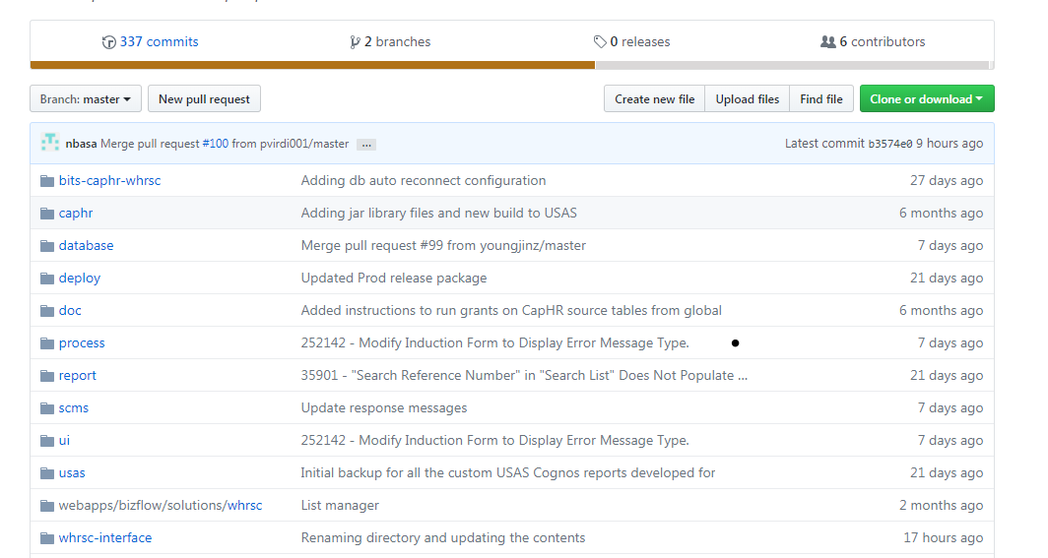

# Deployment Steps

## Database Deployment

Navigate to the WHRSC database directory on GitHub (https://github.com/HHS/WHRSC-BizFlow/tree/master/database) A DBA should perform the following steps using Oracle database client.

### Create Database Views

Log in to the database system as the HHS_WHRSC_HR database user, execute the following script:

WHRSC_HR_DB_USASAPI_01_views_ddl.sql

### Execute View Grants

Log in to the database system as the Oracle System user, execute the following script

WHRSC_HR_DB_USASAPI_02_views_permission.sql

## Configuration

The application.properties file need to be updated depending on the target environment the interface is deployed. The file is located in the /usas/web/src/main/resources/ directory.

### Log Properties

The logging config property should have the path of the logback.xml file.

#Logging properties

logging.config=../webapps/usasapi/WEB-INF/classes/logback.xml

#logging.config=src/main/resources/logback.xml

### WHRSC Database Credentials

Update the highlighted fields with the connection details of the WHRSC database schema.

#WHRSC Source database Configuration

spring.jpa.database-platform=org.hibernate.dialect.Oracle10gDialect

spring.datasource.url=WHRSC JDBC URL

spring.datasource.username= WHRSC schema name

spring.datasource.password=WHRSC database password

spring.datasource.driver-class-name=oracle.jdbc.driver.OracleDriver

## this shows the sql actions in the terminal logs

spring.jpa.show-sql=true

## Build the Source Code

As a system administrator, complete the following steps to build the source code using Apache Ant:

1. Open up a command terminal.
2. Change the directory to the usas/usas-rest-api directory, ex: ‘cd usas/usas-rest-api’
3. Using a text editor, open the usasapi.properties file and modify the JDK location in the following property

jdk.home.1.7=<full_path_to_jdk_home_dir>

1. In the command line, run the ant build script, ex: ‘ant package’
2. Capture the generated WAR file to run the module.

usas/usas-rest-api/dist/usasapi-<version>.war

1. Following are the contents of the WAR after it gets published.

META-INF/MANIFEST.MF

WEB-INF/classes

WEB-INF/classes/application.properties

WEB-INF/classes/log4j.properties

WEB-INF/classes/logback.xml

WEB-INF/lib

## Deployment on Server

1. Log in to the target environment server as the BizFlow service owner (or sudo).
2. Navigate to the Apache Tomcat installation directory. Copy the module WAR file to the designated web application (i.e., tomcat/webapps) directory. Make sure to exclude the version number part of the WAR file since the file name will become the application context name.

* From (build machine):
  + usas/usas-rest-api/dist/usasapi-<version>.war
* To (target environment):
  + <webapps_dir>/usasapi.war

1. Make sure the Tomcat web server is running. If the Tomcat server is not running, start the Tomcat server by running the startup script located at <tomcat_dir>/bin/startup.
2. Wait until the web application is fully deployed. You may watch that the usasapi directory is created under the web application directory, and check properties file under it.

<tomcat_dir>/webapps/usasapi

<tomcat_dir>/webapps/usasapi/WEB-INF/classes/application.properties

1. Configure the properties as outlined above by opening and editing the application.properties file.

## Starting and Testing

After the USA Staffing API Client web application is deployed and configured, perform the following steps:

1. Stop the Tomcat server by running the shutdown script located at <tomcat_dir>/bin/shutdown.
2. Wait until the Tomcat process (i.e. the java process that runs the Tomcat service) is completely shut down.
3. Start the Tomcat by running the startup script located at <tomcat_dir>/bin/startup.
4. The deployed module can be accessed by a web service call with the designated service URL and parameters. For example,
   * http://localhost:8080/usasapi/reportXML/appointment/{requestNumber}
   * http://localhost:8080/usasapi/reportXML/recruitment/{requestNumber}

Replace the protocol, server DNS name, port, and report identifying information as appropriate.

About Deloitte

Deloitte provides audit, tax, consulting, and financial advisory services to public and private clients spanning multiple industries. With a globally connected network of member firms in 140 countries, Deloitte brings world-class capabilities and deep local expertise to help clients succeed wherever they operate. Deloitte's 165,000 professionals are committed to becoming the standard of excellence.

Deloitte's professionals are unified by a collaborative culture that fosters integrity, outstanding value to markets and clients, commitment to each other, and strength from cultural diversity. They enjoy an environment of continuous learning, challenging experiences, and enriching career opportunities. Deloitte's professionals are dedicated to strengthening corporate responsibility, building public trust, and making a positive impact in their communities.

Deloitte refers to one or more of Deloitte Touche Tohmatsu, a Swiss Verein, and its network of member firms, each of which is a legally separate and independent entity. Please see www.deloitte.com/about for a detailed description of the legal structure of Deloitte Touche Tohmatsu and its member firms. Please see <http://www.deloitte.com/us/about> for a detailed description of the legal structure of Deloitte LLP and its subsidiaries.

Internal Usage Statement

This publication is for internal distribution and use only among personnel of Deloitte Touche Tohmatsu, its member firms, and its and their affiliates. Deloitte Touche Tohmatsu, its member firms, and its and their affiliates shall not be responsible for any loss whatsoever sustained by any person who relies on this publication.

Copyright © 2012 Deloitte Development LLC. All rights reserved.

Member of Deloitte Touche Tohmatsu